**Management Principles for Engineers**

***Lecture Notes***



***Compiled By:***

**Career Development Centre**

**SRM IST**

**Table of Contents**

Syllabus 3

UNIT I 4

1.1 Organization- The Individual and the Organization 4

1.2. Management- Primary Functions of Management 5

1.3 Role of management in organization-Advantages of Managing People Well 7

1.4. Types of Managers- Role of managers 8

1.5 Management Thought- Management Roles 9

1.6. Environmental Factors- Internal and External Factors 12

# Syllabus

**18PDH102T- Management Principles for Engineers**

UNIT I

Introduction- Organization- Management- Role of managers- Evolution of management thought- Organization and the environmental factors.

UNIT II

Information and decision making - Information technology and the new workplace - Information and decision making - The decision-making process - Planning - Importance of planning - The planning process - Types of plans used by - Planning tools, techniques and processes

UNIT III

 Organisational control - Types of controls - Motivation theories of motivation - Leading Traits of an ethical leader - The nature of leadership - Leadership traits and behaviours - Issues in leadership development – Organising - Organizing as a management function - Traditional organization structures - Essentials of organizational design - Contingencies in organizational design.

UNIT IV

Strategic management - Sustainable strategic competitiveness - Strategic management goals - The strategic management process - Strategies used by organizations - Strategy formulation - Strategy implementation .

UNIT V

People Management - Diversity and the importance of people - Attracting a quality workforce - The recruiting process - Developing a quality workforce - Environment and diversity - Environment and competitive advantage - Internal environment and organisational culture - Leadership and organisational culture . Ethics - Cultural issues in ethical behaviour - Ethics in the workplace - Ethical dilemma

**TEXT BOOKS:**

Schermerhorn, J.R., Introduction to Management, 13th Edition. Wiley; 2017

Harold Koontz and Heinz Weihrich, Essentials of management: An International & Leadership Perspective, 10th edition, Tata McGraw -Hill Education, 2015.

**REFERENCES:**

Stephen Robbins and Mary Coulter, Fundamentals of Management , 9th edition , Pearson Education India; 2016

Samuel C. Certo and Tervis Certo, Modern management: concepts and skills, Pearson

education, 12th edition, 2012.

Charles W. L. Hill and‎ Steven Mcshane, Principles of Management McGraw Hill Education; Special Indian Edition, 2017

# UNIT I

UNIT I

Course Introduction- Organization- Management- Role of managers- Evolution of management thought- Organization and the environmental factors.

## 1.1 Organization- The Individual and the Organization

**Organization**

**A consciously coordinated social unit, composed of two or more people, that functions on a relatively continuous basis to achieve a common goal or set of goals.**

An organisation is a collection of people working together to achieve a common purpose. It is a unique social phenomenon that enables its members to perform tasks far beyond the reach of individual accomplishment.

*Common Characteristics of Organizations*

* + Have a distinct purpose (goal)
  + Are composed of people
  + Have a deliberate structure

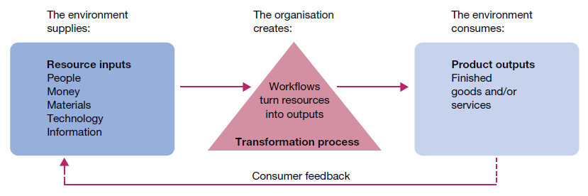

**Fig 1.1.1 Organisation as open systems**

*The changing nature of organizations*

Organisations are certainly undergoing dramatic changes today. Among the many forces and trends in the new workplace, the following organisational transitions set an important context for the study of management.

* Pre-eminence of technology. New opportunities appear with each new development in ICT; they continually change the way organisations operate and how people work.
* Demise of ‘command-and-control’. Traditional hierarchical structures with ‘do as I say’ bosses are proving too slow, conservative and costly to do well in today’s competitive environments. Contemporary management relies on collaboration and coaching.
* Focus on speed. Everything moves fast today; in business those who get products to market first have an advantage, and in any organisation work is expected to be both well done and timely.
* Adoption of networking. Organisations are networked for intense real-time communication and coordination, internally among departments and externally with partners, contractors, suppliers and customers.
* Belief in empowerment. Demands of the new economy place premiums on high-involvement and participatory work settings that rally the knowledge, experience and commitment of all members.
* Emphasis on teamwork. Today’s organisations are less vertical and more horizontal in focus; they are increasingly driven by teamwork that pools talents for creative problem-solving.
* New workforce expectations. A new generation of workers brings to the workplace less tolerance for hierarchy, more informality and more attention to performance merit than to status and seniority.
* Concern for work–life balance. As society increases in complexity, workers are forcing organizations to pay more attention to balance in the often-conflicting demands of work and personal affairs.

## 1.2. Management- Primary Functions of Management

*Management is the process of designing and maintaining an environment in which individuals, working together in groups, efficiently accomplish selected aims*

Many management thinkers have defined management in their own ways. For example, Van Fleet and Peterson define management, ‘as a set of activities directed at the efficient and effective utilization of resources in the pursuit of one or more goals.’

Megginson, Mosley and Pietri define management as ‘working with human, financial and physical resources to achieve organizational objectives by performing the planning, organizing, leading and controlling functions‘.

Kreitner’s definition of management:

‘Management is a problem solving process of effectively achieving organizational objectives through the efficient use of scarce resources in a changing environment.’

According to F.W. Taylor, ‘Management is an art of knowing what to do, when to do and see that it is done in the best and cheapest way‘.

According to Harold Koontz, ‘Management is an art of getting things done through and with the people in formally organized groups. It is an art of creating an environment in which people can perform and individuals and can co-operate towards attainment of group goals.‘

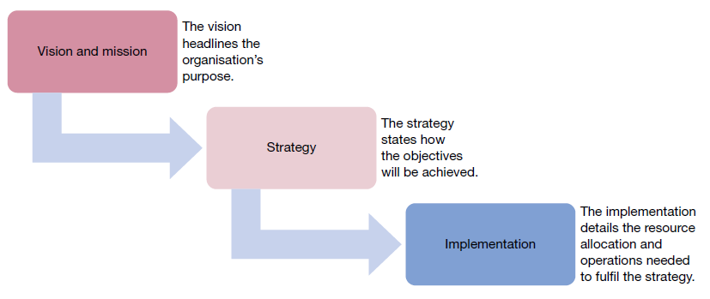

**Fig 1.2.1 Process of management**

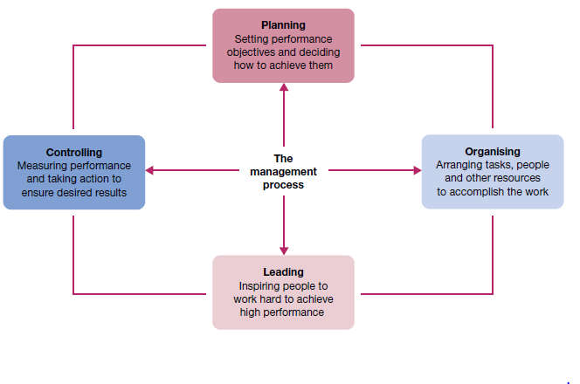

**Fig 1.2.2 Functions of management**

**Functional Approach**

***Planning***

In management, planning is the process of setting performance objectives and determining what actions should be taken to accomplish them. Through planning, a manager identifies desired work results and the means to achieve them. Planning involves selecting missions and objectives and the actions to achieve them, it requires decision making, i.e. choosing future courses of action from among alternatives.

Planning as a process typically involves the following steps

Selection of goals for the organization

Establishment of goals for each of the organization’s sub-units

Establishment of programs for achieving goals in a systematic manner.

***Controlling***

A key issue in how well plans are implemented is how well the organisation adapts to rapid change. In today’s dynamic times, things do not always go as expected and plans must be modified and redefined with the passage of time. The management function of controlling is the process of measuring work performance, comparing results with objectives, and taking corrective action as needed. Through controlling, managers maintain active contact with people in the course of their work, gather and interpret reports on performance, and use this information to plan constructive action and change. Through measurement management is able to track progress against objectives.

Managers at all levels engage in the managerial function of controlling to some degree.

Two traditional control techniques are budget and performance audits. An audit involves

a physical examination and verification of the organization’s records and supporting

documents. A budget audit provides information about where the organization is with

respect to procedures followed for financial planning and control, whereas a performance

audit might try to determine whether the figures reported are a reflection of actual

performance.

Controlling is not just limited to organization’s financial state, but also spans across

areas like operations, compliance with company policies and other regulatory policies,

including many other activities within the organization. The management functions thus most effectively cover the broad scope of a manager’s duties and responsibilities. Though the nature and complexities faced by businesses have undergone a vast change over the years the functions of management remain the same

***Organising***

Even the best plans may fail without effective implementation. The implementation phase begins with organising — the process of assigning tasks, allocating resources and arranging the coordinated activities of individuals and groups to implement plans. Through organising, managers turn plans into actions by defining jobs, assigning staff and supporting them with technology and other resources.

Organizing involves the following steps:

Creating the organizational structure

Making organizational design decisions

Making job design decisions

***Leading***

In management, leading is the process of arousing people’s enthusiasm to work hard and direct their efforts to fulfil plans and accomplish objectives. Through leading, managers build commitments to a common vision, encourage activities that support goals, and influence others to do their best work on the organisation’s behalf.

.

## 1.3 Role of management in organization-Advantages of Managing People Well

**1.3.1 Features of Management**

## Continuous and never ending process

Management is a Process. It includes four main functions, viz., [Planning](https://kalyan-city.blogspot.com/2010/06/planning-first-primary-important.html), Organising, Directing and Controlling. The manager has to Plan and Organise all the activities. He had to give proper Directions to his subordinates. He also has to Control all the activities. The manager has to perform these functions continuously. Therefore, management is a continuous and never-ending process.

## Getting things done through people

The managers do not do the work themselves. They get the work done through the workers. The workers should not be treated like slaves. They should not be tricked, threatened or forced to do the work. A favorable work environment should be created and maintained.

## Result oriented science and art

Management is result oriented because it gives a lot of importance to "**Results**". Examples of Results like, increase in market share, increase in profits, etc. Management always wants to get the best results at all times.

## Multidisciplinary in nature

Management has to get the work done through people. It has to manage people. This is a very difficult job because different people have different emotions, feelings, aspirations, etc. Similarly, the same person may have different emotions at different times. So, management is a very complex job. Therefore, management uses knowledge from many different subjects such as Economics, Information Technology, Psychology, Sociology, etc. Therefore, it is multidisciplinary in nature.

## A group and not an individual activity

Management is not an individual activity. It is a group activity. It uses group (employees) efforts to achieve group (owners) objectives. It tries to satisfy the needs and wants of a group (consumers). Nowadays, importance is given to the team (group) and not to individuals.

## Follows established principles or rules

Management follows established principles, such as division of work, discipline, unity of command, etc. These principles help to prevent and solve the problems in the organization.

## Aided but not replaced by computers

Nowadays, all managers use computers. Computers help managers to make accurate decisions. However, computers can only help management. Computers cannot replace management. This is because management takes final responsibility. Thus Management is aided (helped) but not replaced by computers.

## Situational in nature

Management makes plans, policies, and decisions according to the situation. It changes its style according to the situation. It uses different plans, policies, decisions, and styles for different situations.

The manager first studies the full present situation. Then he draws conclusions about the situation. Then he makes plans, decisions, etc., which are best for the present situation. This is called **Situational** Management.

## Need not be an ownership

In small organizations, management and ownership are one and the same. However, in large organizations, management is separate from ownership. The managers are highly qualified professionals who are hired from outside. The owners are the shareholders of the company.

## Both an art and science

Management is result-oriented. Therefore, it is an Art. Management conducts continuous research. Thus, it is also a Science.

## Management is all pervasive

Management is necessary for running a business. It is also essential for running a business, educational, charitable and religious institutions. Management is a must for all activities, and therefore, it is all pervasive.

## Management is intangible

Management is intangible, i.e. it cannot be seen and touched, but it can be felt and realized by its results. The success or failure of management can be judged only by its results. If there is good discipline, good productivity, good profits, etc., then the management is successful and vice-versa.

## Uses a professional approach in work

Managers use a professional approach to get the work done from their subordinates. They delegate (i.e. give) authority to their subordinates. They ask their subordinates to give suggestions for improving their work. They also encourage subordinates to take the initiative. Initiative means to do the right thing at the right time without being guided or helped by the superior.

## Dynamic in nature

Management is dynamic in nature. That is, [management is creative](https://kalyan-city.blogspot.com/2011/03/management-is-innovative-art-that.html) and innovative. An organization will survive and succeed only if it is dynamic. It must continuously bring in new and creative ideas, new products, new product features, new ads, new marketing techniques, etc.

**1.3.2 Importance of Management**

• **It helps in Achieving Group Goals -** It arranges the factors of production, assembles and organizes the resources, integrates the resources in effective manner to achieve goals. It directs group efforts towards achievement of pre-determined goals. By defining objective of organization clearly there would be no wastage of time, money and effort. Management converts disorganized resources of men, machines, money etc. into useful enterprise. These resources are coordinated, directed and controlled in such a manner that enterprise work towards attainment of goals.

• **Optimum Utilization of Resources -** Management utilizes all the physical & human resources productively. This leads to efficacy in management. Management provides maximum utilization of scarce resources by selecting its best possible alternate use in industry from out of various uses. It makes use of experts, professional and these services leads to use of their skills, knowledge, and proper utilization and avoids wastage. If employees and machines are producing its maximum there is no under employment of any resources.

• **Reduces Costs -** It gets maximum results through minimum input by proper planning and by using minimum input & getting maximum output. Management uses physical, human and financial resources in such a manner which results in best combination. This helps in cost reduction.

• **Establishes Sound Organization -** No overlapping of efforts (smooth and coordinated functions). To establish sound organizational structure is one of the objective of management which is in tune with objective of organization and for fulfillment of this, it establishes effective authority & responsibility relationship i.e. who is accountable to whom, who can give instructions to whom, who are superiors & who are subordinates. Management fills up various positions with right persons, having right skills, training and qualification. All jobs should be cleared to everyone.

• **Establishes Equilibrium -** It enables the organization to survive in changing environment. It keeps in touch with the changing environment. With the change is external environment, the initial co-ordination of organization must be changed. So it adapts organization to changing demand of market / changing needs of societies. It is responsible for growth and survival of organization.

• **Essentials for Prosperity of Society -** Efficient management leads to better economical production which helps in turn to increase the welfare of people. Good management makes a difficult task easier by avoiding wastage of scarce resource. It improves standard of living. It increases the profit which is beneficial to business and society will get maximum output at minimum cost by creating employment opportunities which generate income in hands. Organization comes with new products and researches beneficial for society.

**1.4. Types of Managers- Role of managers**

**Manager**

Someone who works with and through other people by coordinating their work activities in order to accomplish organizational goals

**Levels of Managers**

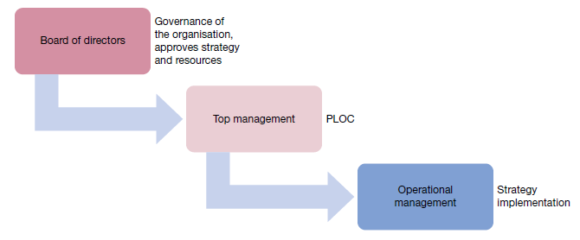

**1.4.1 Levels of Managers**

**Skills and Managerial levels**

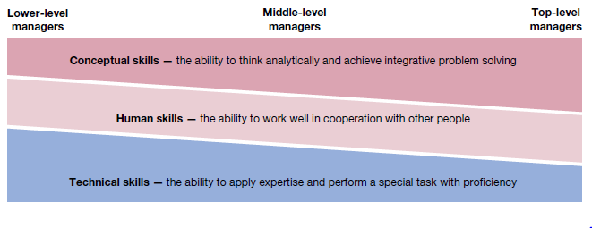

**Fig 1.4.2 Skills and Managerial levels**

**Technical skills**  
The ability to apply specialized knowledge or expertise

**Human skills**The ability to work with, understand, and motivate other people, both individually and in groups.

**Conceptual Skills**The mental ability to analyze and diagnose complex situations.

**Types of managers**

**Line managers** are responsible for work activities that make a direct contribution to the

organisation’s outputs. For example, the general manager, retail manager and department supervisors of a local department store all have line responsibilities. Their jobs in one way or another are directly related to the sales operations of the store. **Staff managers**, on the other hand, use special technical expertise to advise and support the efforts of line workers. In a department store, the director of human resources and the chief financial officer would have staff responsibilities.

In business, **functional managers** have responsibility for a single area of activity, such as finance, marketing, production, human resources, accounting or sales. **General managers** are responsible for more complex units that include many functional areas. An example is a plant manager who oversees many separate functions, including purchasing, manufacturing, warehousing, sales, personnel and accounting. It is not unusual for managers working in public or not‐for‐profit organisations to be called **administrators**. Examples include hospital administrator, public administrator and local government administrator.

**Mintzberg’s Management Roles Approach**

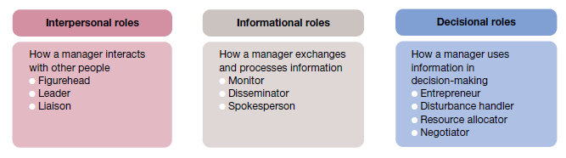

**Fig 1.4.3 Mintzberg’s Management Roles Approach**

The way in which the Mintzberg Managerial Roles are carried out, are influenced by individual and situational factors. [Henry Mintzberg](https://www.toolshero.com/toolsheroes/henry-mintzberg/) initially divided the ten managerial Roles roles into three sub categories:

* Interpersonal contact
* Information processing
* Decision making

**Interpersonal contact**  
Interpersonal contact concerns the contact between the manager and the people in his environment. For example, subordinates, other managers, the board of directors, the works council, customers and suppliers.

The following Mintzberg Managerial Roles are primarily concerned with interpersonal contact:

### 1. Figurehead

As head of a department or an organisation, a manager is expected to carry out ceremonial and/or symbolic duties. A manager represents the company both internally and externally in all matters of formality.He is a networker but he also serves as an exemplary role model. He is the one who addresses people celebrating their anniversaries, attends business dinners and receptions.

### 2. Leader

In his leading role, the manager motivates and develops staff and fosters a positive work environment. He coaches and supports staff, enters into (official) conversations with them, assesses them and offers education and training courses.

### 3. Liason

A manager serves as an intermediary and a linking pin between the high and low levels. In addition, he develops and maintains an external network. As a networker he has external contacts and he brings the right parties together. This will ultimately result in a positive contribution to the organization.

**Information processing**  
According to [Henry Mintzberg](https://www.toolshero.com/toolsheroes/henry-mintzberg/), the managerial role involves the processing of information which means that they send, pass on and analyze information. Managers are linking pins; they are expected to exchange flows of vertical information with their subordinates and horizontal flows of information with their fellow managers and the board of directors. Further more, managers have the responsibility to filter and transmit information that is important for both groups. The following Mintzberg Managerial Roles fall under process information:

### 4. Monitor

As a monitor the manager gathers all internal and external information that is relevant to the organization.He is also responsible for arranging, analyzing and assessing this information so that he can easily identify problems and opportunities and identify changes.

### 5. Disseminator

As a disseminator the manager transmits factual information to his subordinates and to other people within the organization.This may be information that was obtained either internally or externally.

### 6. Spokesman

As a spokesman the manager represents the company and he communicates to the outside world on corporate policies, performance and other relevant information for external parties.

**Decision-making**  
Managers are responsible for decision-making and they can do this in different ways at different levels. The leadership style is important in decision-making.

An authoritarian leader is sooner inclined to make decisions independently than a democratic leader. The following Mintzberg Managerial Roles fall under decision-making:

### 7. Entrepreneur

As an entrepreneur, the manager designs and initiates changes and strategies.

### 8. Disturbance handler

In his managerial role as disturbance handler, the manager will always immediately respond to unexpected events and operational breakdowns. He aims for usable solutions. The problems may be internal or external, for example conflict situations or the scarcity of raw materials. .

### 9. Resource allocator

In his resource allocator role, the manager controls and authorizes the use of organizational resources.He allocates finance, assigns employees, positions of power, machines, materials and other resources so that all activities can be well-executed within the organization.

### 10. Negotiator

As a negotiator, the manager participates in negotiations with other organizations and individuals and he represents the interests of the organization.This may be in relation to his own staff as well as to third parties. For example salary negotiations or negotiations with respect to procurement terms.

## 

## 1.5 Management Thought- Management Roles

*Management Thought (Various approach to Management/Evolution of Management Thought)*

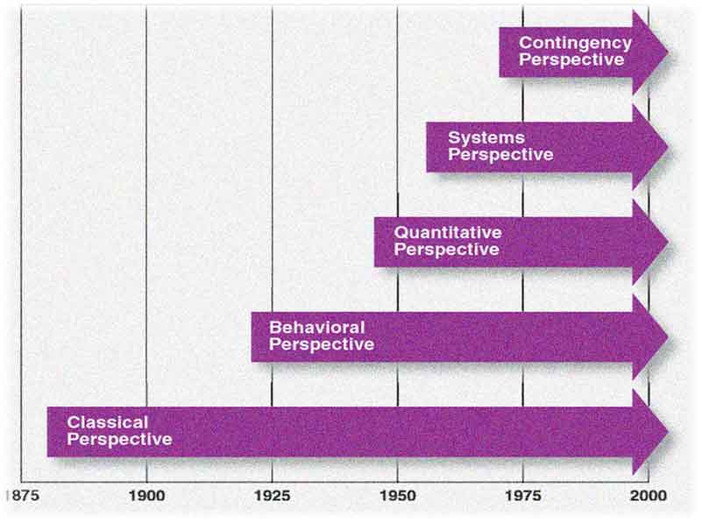

**Classical approaches to management**

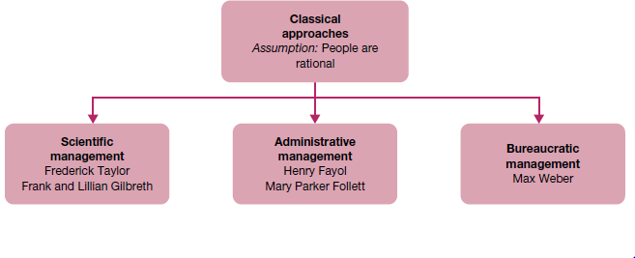

**Fig 1.5.1 Classical approaches to management**

* Frederick Taylor’s four principles of scientific management focused on the need to carefully select, train and support workers for individual task performance.
* Henri Fayol suggested that managers should learn what are now known as the management functions of planning, organising, leading and controlling.
* Max Weber described bureaucracy with its clear hierarchy, formal rules and well-defined jobs as an ideal form of organisation.
* Jaques emphasised hierarchy in organisations and the crucial role of the manager.

**Behavioural approaches to management**

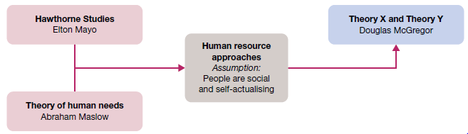

**Fig 1.5.2 Behavioural approaches to management**

The human resource approaches shifted attention towards the human factor as a key element in organisational performance.

* The historic Hawthorne Studies suggested that work behaviour is influenced by social and psychological forces and that work performance may be improved by better ‘human relations’.
* Abraham Maslow’s hierarchy of human needs introduced the concept of self-actualisation and the potential for people to experience self-fulfilment in their work.
* Douglas McGregor urged managers to shift away from Theory X and towards Theory Y thinking, which views people as independent, responsible and capable of self-direction in their work.
* Peter Drucker’s influence on management thinking continues to be felt as a humanizing common sense approach to the many and complicated tasks involved in managing contemporary organisations.

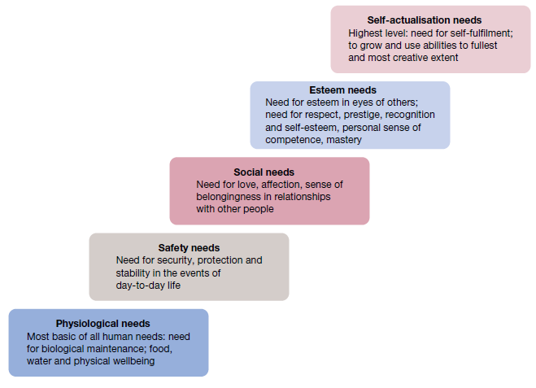

**Fig 1.5.3 Maslow’s hierarchy of human needs**

**Quantitative approaches to management**

The availability of high-powered desktop computing provides new opportunities for mathematical methods to be used for problem-solving.

* Many organisations employ staff specialists in quantitative management science and operations research to solve problems.
* Quantitative techniques in common use include various approaches to forecasting, linear programming and simulation, among others.

**Modern approaches to management**

Organisations are complex open systems that interact with their external environments to transform resource inputs into product outputs.

* Resource acquisition and customer satisfaction are important requirements in the organisation–environment relationship.
* Organisations are composed of many internal subsystems that must work together in a coordinated way to support the organisation’s overall success.
* Contingency thinking avoids ‘one best way’ arguments, and recognises the need to understand situational differences and respond appropriately to them.
* *In the 21st century:* The commitment to meet customer needs 100 per cent of the time guides organisations towards total quality management and continuous improvement of operations.
* The global economy is a dramatic influence on organisations today, and opportunities abound to learn new ways of managing from practices in other countries.
* This is the age of information in which knowledge and knowledge workers are major resources of modern society.
* New managers must accept and excel at leadership responsibilities to perform as global strategists, technology masters, consummate politicians and leader–motivators.

**Henry Fayol’s Principles of Management**

One of the oldest and most popular approaches, Henry Fayol’s theory holds that administration of all organizations – whether public or private, large or small – requires the same rational process or functions.

This school of thought is based on two assumptions −

* Although the objective of an organization may differ (for example, business, government, education, or religion), yet there is a core management process that remains the same for all institutions.
* Successful managers, therefore, are interchangeable among organizations of differing purposes. The universal management process can be reduced to a set of separate functions and related principles.

Fayol identifies fourteen universal principles of management, which are aimed at showing managers how to carry out their functional duties.

|  |  |  |
| --- | --- | --- |
| **S.No** | **Universal principles of management** | **Managers Functional Duties** |
| 1 | Specialization of labor | This improves the efficiency of labor through specialization, reducing labor time and increasing skill development. |
| 2 | Authority | This is the right to give orders which always carry responsibility commensurate with its privileges. |
| 3 | Discipline | It relies on respect for the rules, policies, and agreements that govern an organization. Fayol ordains that discipline requires good superiors at all levels. |
| 4 | Unity of command | This means that subordinates should receive orders from one superior only, thus avoiding confusion and conflict. |
| 5 | Unity of direction | This means that there should be unity in the directions given by a boss to his subordinates. There should not be any conflict in the directions given by a boss. |
| 6 | Subordination of individual interest to common good | According to this principle, the needs of individuals and groups within an organization should not take precedence over the needs of the organization as a whole. |
| 7 | Remuneration | Wages should be equitable and satisfactory to employees and superiors. |
| 8 | Centralization | Levels at which decisions are to be made should depend on the specific situation, no level of centralization or decentralization is ideal for all situations. |
| 9 | Scale of chain | The relationship among all levels in the organizational hierarchy and exact lines of authority should be unmistakably clear and usually followed at all times, excepting special circumstances when some departure might be necessary. |
| 10 | Order | There should be a place for everything, and everything should be in its place. This is essentially a principle of organization in the arrangement of things and people. |
| 11 | Equity | Employees should be treated equitably in order to elicit loyalty and devotion from personnel. |
| 12 | Personal tenure | Views unnecessary turnover to be both the cause and the effect of bad management; Fayol points out its danger and costs. |
| 13 | Initiative | Subordinates should be encouraged to conceive and carryout ideas. |
| 14 | Esprit de corps | Team work, a sense of unity and togetherness, should be fostered and maintained. |

## 1.6. Environmental Factors- Internal and External Factors

Major elements of an organisation’s general environment

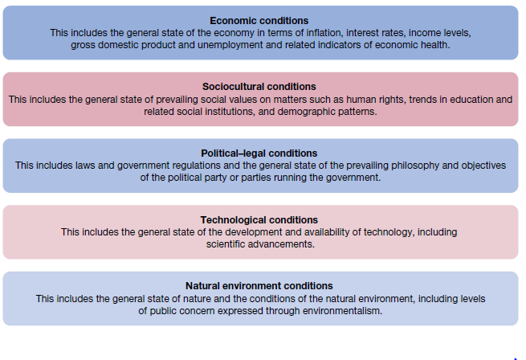

**Fig 1.6.1 Major elements of an organisation’s general environment**

**The specific environment**

The **specific environment** consists of the actual organisations, groups and people with whom an organisation interacts and conducts business. These are environmental elements of direct consequence to the organisation as it operates on a day‐to‐day basis. The specific environment is often described in terms of **stakeholders** — the individuals, groups and institutions who are affected in one way or another by the organisation’s performance.

**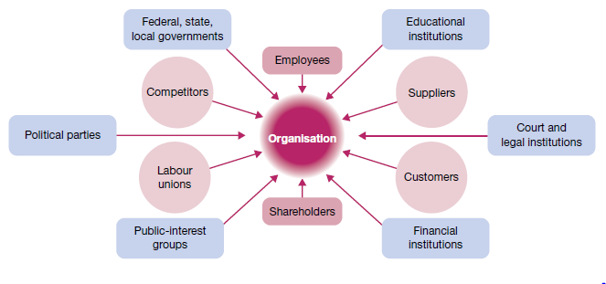  
Fig 1.6.2 Multiple stakeholders in the environment of organizations**

Sometimes called the *task environment*, the specific environment and the stakeholders are distinct for each organisation. They can also change over time according to the company’s unique customer base, operating needs and circumstances. Important stakeholders common to the specific environment of most organisations include:

* *customers* — specific consumer or client groups, individuals and organisations that purchase the organisation’s goods and/or use its services
* *suppliers* — specific providers of the human, information and financial resources and raw materials needed by the organisation to operate
* *competitors* — specific organisations that offer the same or similar goods and services to the same consumer or client groups
* *regulators* — specific government agencies and representatives, at the local, state and national levels, that enforce laws and regulations affecting the organisation’s operations.

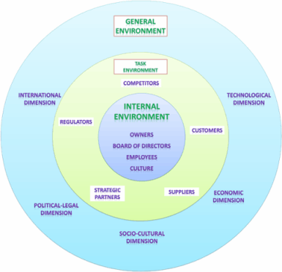

**Fig 1.6.3 Multiple stakeholders in the environment of organizations - 2**

**Environmental uncertainty**

The fact is that many organisations today face great uncertainty in their external environments. In this sense, **environmental uncertainty** means that there is a lack of complete information regarding what developments will occur in the external environment. This makes it difficult to predict future states of affairs and to understand their potential implications for the organisation. Figure below describes environmental uncertainty along two dimensions — complexity, or the number of different factors in the environment, and the rate of change in these factors.

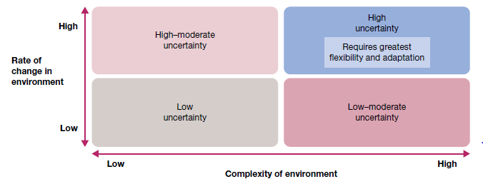

**Fig 1.6.3 Dimensions of uncertainty in organisational environments**